SmartCare Guide

ACT/FACT Programs

Entering Monthly Bundled & Unbundled Services Workflow Version 1.0
ACT/FACT Monthly Bundled Rate & Unbundled Service Entry in SmartCare

Open Client to ACT/FACT Program
Follow SmartCare Workflows when receiving referral(s) and opening clients to your program and requesting prior authorization.
SmartCare Workflow for MH-SUD 10.08.24.pdf
Authorization for Services Process in SmartCare

Entering ACT/FACT Services in SmartCare using the Bundled Rate Mode of Delivery

- Open the service note screen. Review and complete the service details
  - Change the status to “Show” – service must be in Show status until step 5.
  - Confirm the Program, Procedure, Location, Clinician, and Mode of Delivery are accurate.
    - Mode of Delivery must be selected for “BHC-ACT/FACT Monthly Bundle”
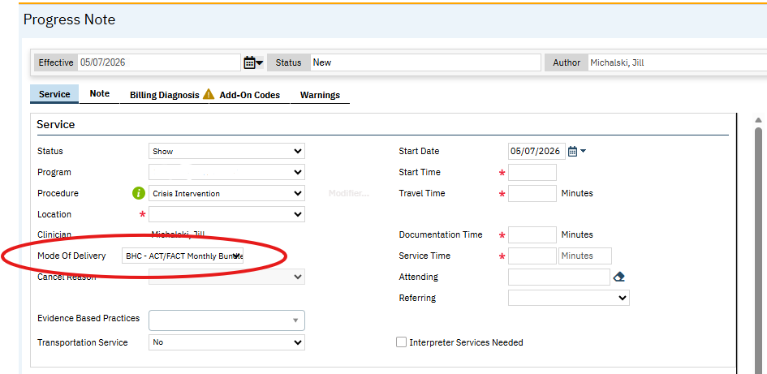
    - Enter the actual procedure code for the service provided and Place of Service

  - Confirm the Start Date is accurate and complete the time fields.
    - Travel Time – any time spent traveling to or from this service appointment. This will not be billed but is used for tracking.
    - Documentation Time – any time spent documenting the service or related forms.
    - Service Time – the length of the service time, even if the client was not present.
  - Leave Attending and Referring blank.
  - If you are in a Mental Health program, you may enter any Evidenced Based Practices you provided. This is used for CSI reporting, so you can only select up to 3 and the options are limited to CSI reporting values.
  - Enter whether Transportation Service was provided or not. If the client does not have the Transportation Service checkbox checked in the Client Information, this will automatically populate as “No”. For services done via phone or telehealth, this may be marked “N/A.”
  - Check Interpreter Services Needed if applicable.
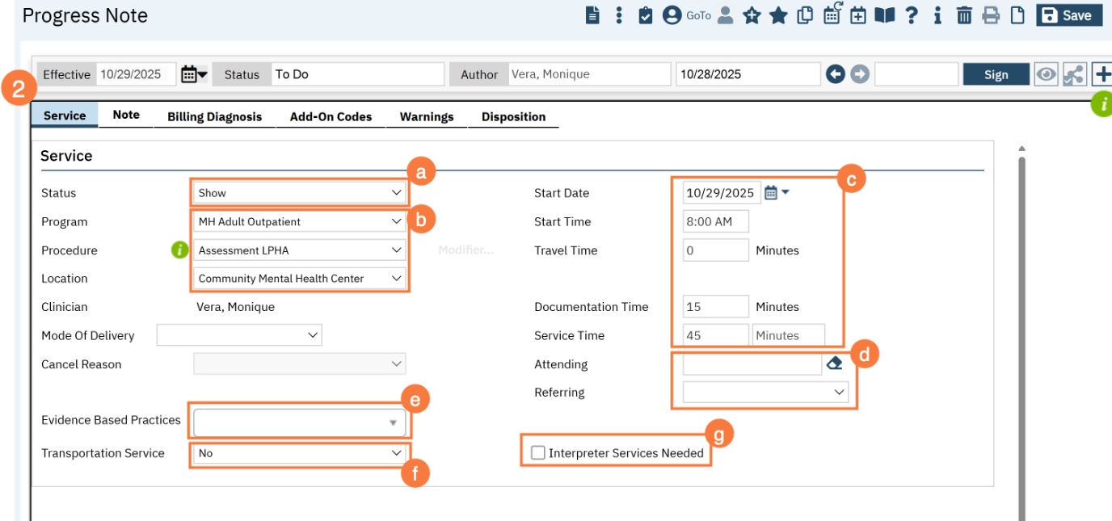
  - In the Custom Fields section, enter Interpreter and Language information if applicable.
    - Was Interpreter Utilized – If you mark Yes, indicate who the interpreter was. This could be an agency name or the name of a person. If an interpreter was not needed because you, the provider, did the service in the client’s native language, you can leave this blank.
    - Indicate the language the service was provided in.
  - In the Custom Fields section, there is a section for Comments. This is usually used for no-shows and cancellations. Your Front Desk staff may also put notes for you in this section, such as “the client called and will be 5 minutes late to the appointment.” Keep in mind that anything entered in this section will be considered part of the client’s record and can be viewed by the client at any time.
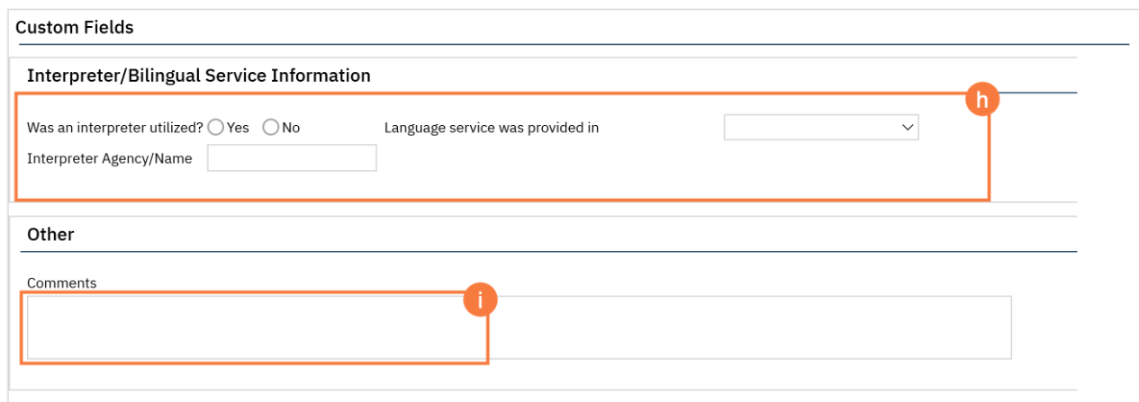
- If the status of the service is “Show”, you may now click on the Note tab. Complete the progress note tab. This note type may look different depending on the procedure code you have chosen. Most will include 3 fields: the Problem List section, the Note section, and the Care Plan section.
  - If you want to add problems to the problem list, you can do so here. Search for the problem using either the Code or Description field, enter the start date, and select your program. Then click Insert.
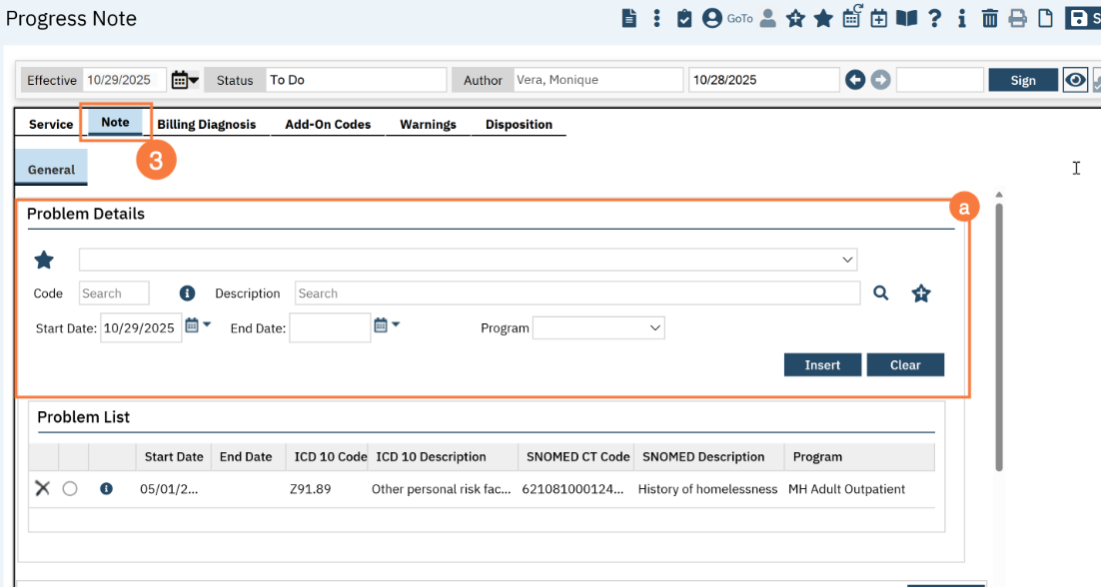
  - Select which problems you addressed in today’s session. If you added a problem in step 3a above and don’t see the problem on this list, click the Refresh button.
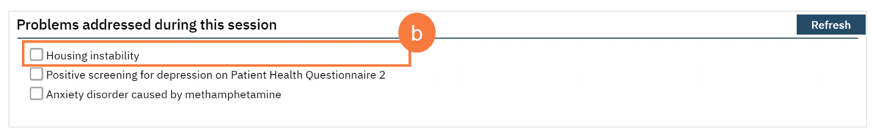
  - Enter your note in the Information section. This should include all your usual clinical information, such as your interventions and the client’s response to the interventions.
  - Enter your plan of care in the Care Plan section. For services that require a treatment plan with specific items, this is where the treatment plan is entered. This information will pull forward from the most recent service note in the same program. There may be text templates available for specific treatment plan requirements.
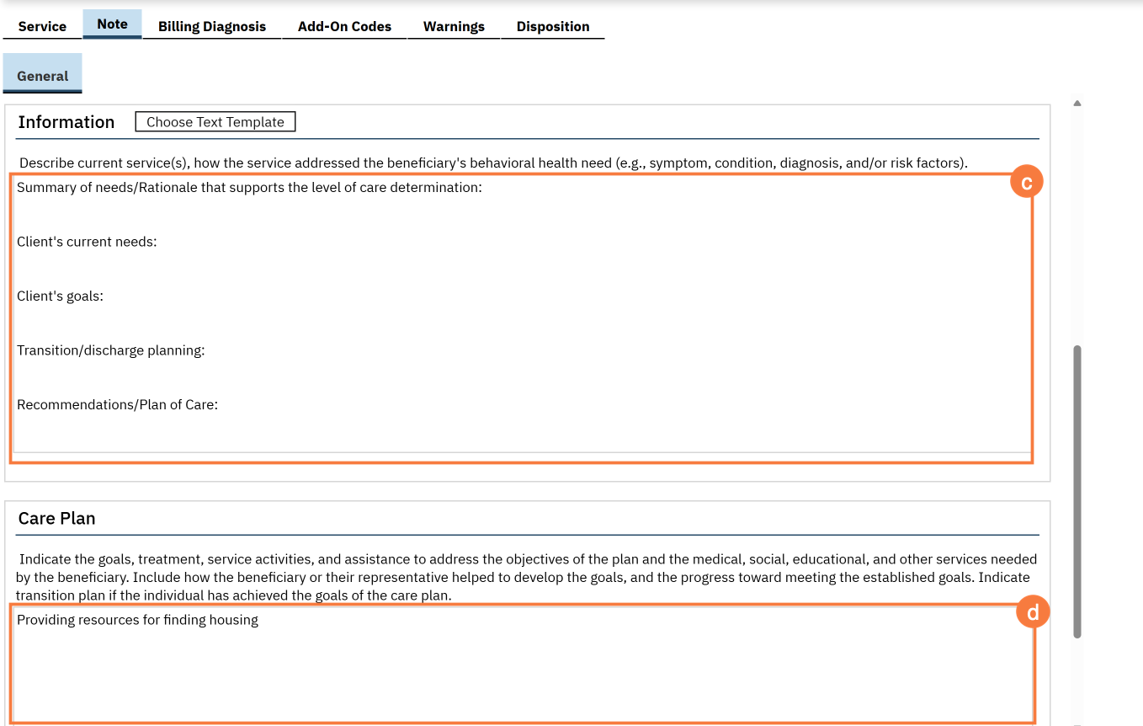

- The Billing Diagnosis tab will show you which diagnoses will be pulled onto the billing. You should generally ignore this tab for ongoing services. However, if you need to change the billing order, for example you want this note to focus on the secondary diagnosis, you can re-order the diagnoses to match your service without changing the overarching diagnosis form.
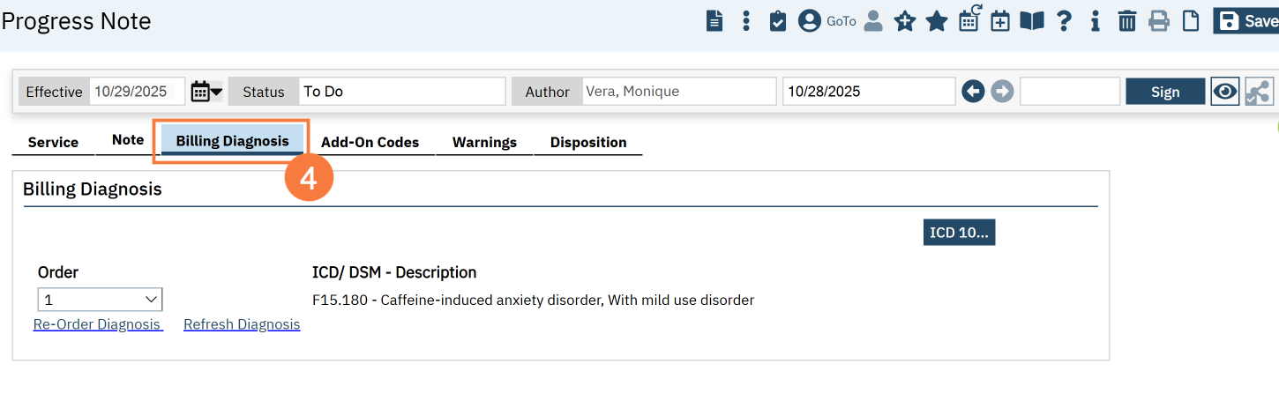

- Return to the Service Tab and change Status to Pending. It is very important that you place the service in Pending Status after you complete your documentation in order to be able to sign the note. Services must remain in Pending Status in order to prevent them from running through the nightly job and moving to Complete Status until the end of the month review to determine if services to the client met the threshold to claim the monthly bundled rate(s) or require unbundling. (see workflow: Reviewing & Adjusting Services for Bundled/Unbundled Claims).
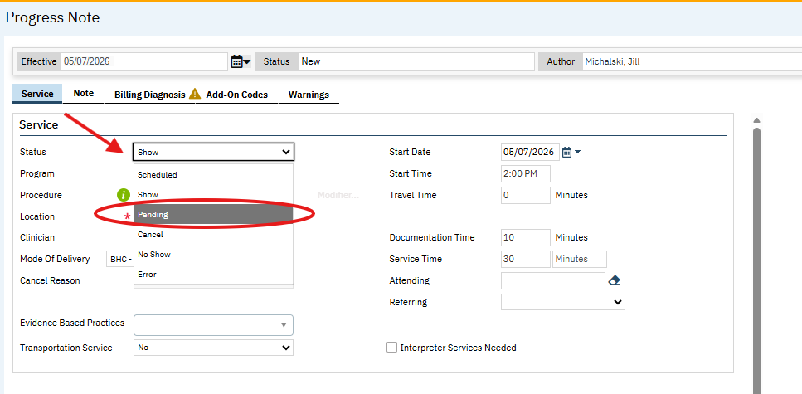

- When you are finished with your documentation and have placed the note in Pending status, click Sign.
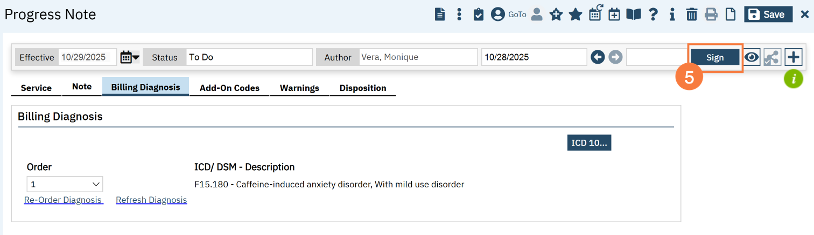
Services will remain in Pending status until end of month review to determine if services provided to the client meet threshold for either the Full or Partial Monthly Bundled Rate. This is very important to ensure that the service does not go through the nightly job, and you will be able to edit the service details at the end of the month.

Review of ACT/FACT Services for Bundled Rate Threshold and Claiming
ACT/FACT services are claimed and billed under either a Full Monthly Rate Bundle or a Partial Monthly Bundled Rate based on the services provided during a single calendar month.
At the end of each calendar month, Programs will:
- Run the COSD Client Services Report (My Office) for all services provided for the calendar month no later than 5th of the month following the month in which you are claiming services. (See Pg 11 for Guidance on running COSD Client Services Report)
  - Providers are reminded that DHCS requires all services to be documented within 3 days of date of service; all services for the month must have been entered before running the COSD Client Services Report (My Office).
- Review all services provided to the client to determine if the encounters meet the criteria to claim the Full or Partial bundled rate.
  - The bundled rate will cover the first 12 encounters for the ACT/FACT in a month.
  - Services over 12 may be “unbundled” and submitted to DHCS separately from the bundled service rate.
    - Example: client receives 15 contacts in a month; program can bill the bundled rate for contacts 1-12 and bill the unbundled FFS rate for contacts 13-15.
  - If the client received less than the minimum required services to meet threshold for the Partial Bundled Rate, all services should be “unbundled” and billed to DHCS at the FFS rate.
- Edit all services using the Edit Service button to create new version of service and change the MOD to unbundle the service if needed and change the status from Pending to Show. Complete these edits no later than the 15th of the month following the month to be claimed.

Unbundling Services and Moving Services to Show
- Run the COSD Client Services Report for all clients at the end of the month – reminder - all services for the month being reviewed for billing must be entered before running this report.
  - Providers are reminded that DHCS requires all services to be documented within 3 days of date of service.
  - Recommend to run report on 5th of month to ensure all services have been entered into SmartCare for the previous month.
- Filter Report by client and review service details to determine whether client contacts meet threshold for Full or Partial Month Rate.

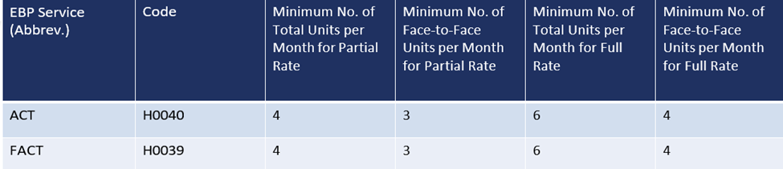

- Depending on the number of contacts provided during the month – the following actions will be needed for each service:
  - Partial Monthly Bundle Rate: Client received minimum of 4 service encounters and at least 3 of these services were face to face with the client:
    - Leave MOD for BHC-ACT/FACT Bundle unchanged
    - Change Status from Pending to Show
  - Full Monthly Bundle Rate: Client received 6-12 service encounters, at least 4 of these services were face to face with the client.
    - Leave MOD for BHC-ACT/FACT Bundle unchanged
    - Change Status from Pending to Show
  - Client received > 12 service encounters and met minimum for Full Bundled Rate – for Services #13 and beyond
    - Change MOD to remove BHC-ACT/FACT Bundle and select appropriate MOD
    - Change Status from Pending to Show
    - Unbundled services will bill separately at the individual FFS rates for the service type provided in addition to the monthly bundled rate.
  - Client received less than 4 service encounters for the month
    - Threshold not met to claim a bundled rate – all services must be unbundled and submitted as unbundled services.
    - Change MOD to remove BHC-ACT/FACT Bundle and select appropriate MOD
    - Change Status from Pending to Show
Editing the Service Note to change MOD* and Status
1. Select Client
2. Open Services/Notes (Client) List Page
3. Open Service Note to be edited
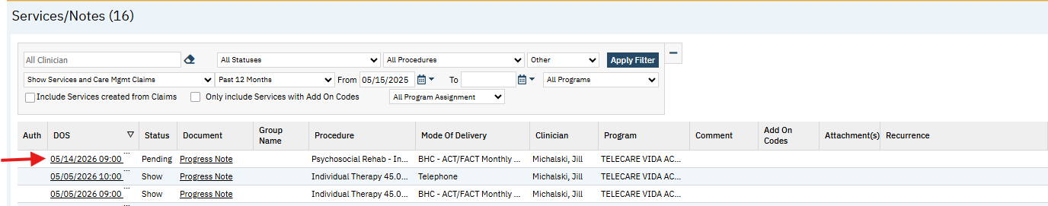

4.Select Edit Icon
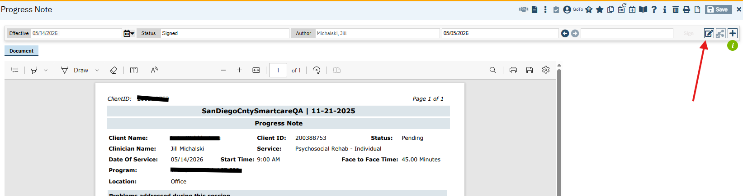

5. Pop Up Message: “A new version of this document is about to be created. Do you wish to continue?” Select OK
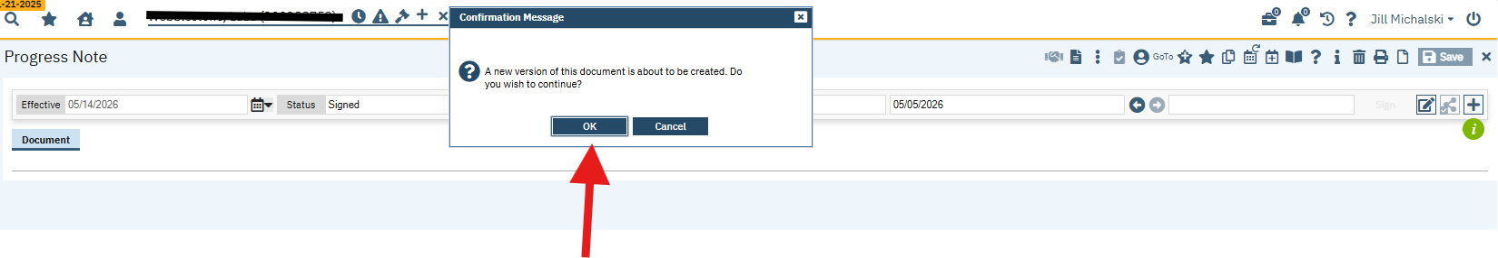

6. Change Status to Show and if applicable, change the MOD* from the ACT/FACT Monthly Bundle to the appropriate MOD for services that should be excluded from the bundled rate.
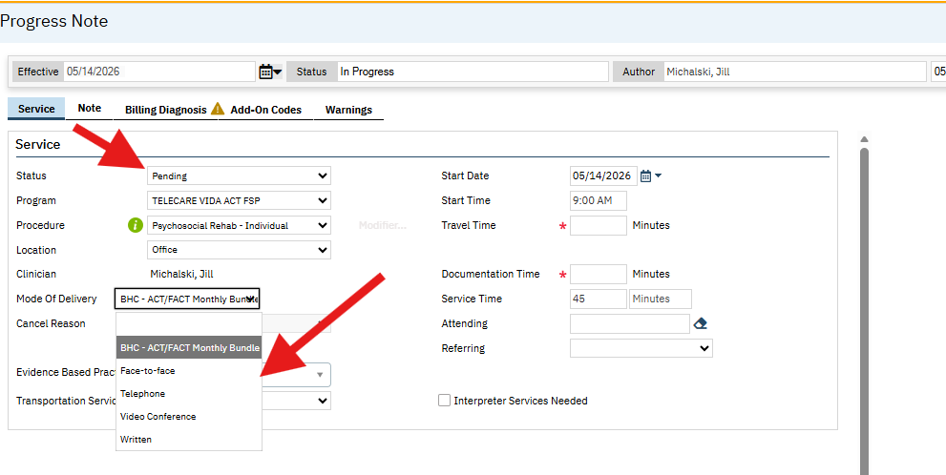
7. Sign Service Note.
* All Services will require the Status to be changed to Show but not all services will require the MOD to be changed. MOD is dependent on whether the service will be part of the bundle or will be claimed separately as an unbundled service.

COSD Client Services Report (My Office)
The COSD Client Services Report (My Office) provides a comprehensive view of client service activities, encompassing details on service delivery, client demographics, program participation, and staff involvement over the specified date range. This report will be used to review all services provided to the client for the specified month in order to determine if the threshold was met to claim the Full or Partial Monthly Bundled rate and to identify those services which may should be unbundled and claimed separately as FFS. *CalMHSA is developing and testing a BH-Connect EBP Monthly Bundled Rate Report, however timeline for release is pending.
How to Run the COSD Client Services Report (My Office)
- Click the Search Icon.
- Type the Name of the report in the search bar.
- Click to select the report.

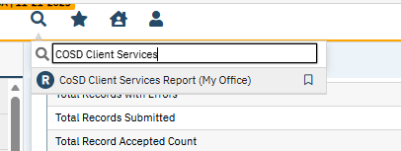

- A new window will open, enter the parameters for the report:
  - Enter Date of Service From (1st of month, i.e.: 4/1/2026)
  - Enter Date of Service To (last date of month, i.e.: 4/30/2026).
  - Enter Service Status as Pending
  - Enter Program Code (Name of Your Program)
  - Select All for Procedure Name(s)
    - you will want all services provided to the client by your program included to determine criteria for Full or Partial Month bundled rate and identify any services that may need to be unbundled.

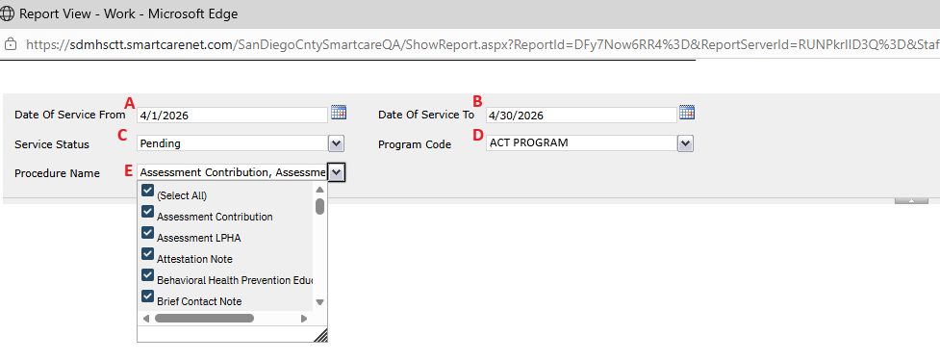

- Click View Report.
- The report will be displayed. To export the report, click the Save/Export button drop down arrow.
- Select Excel or other export option.

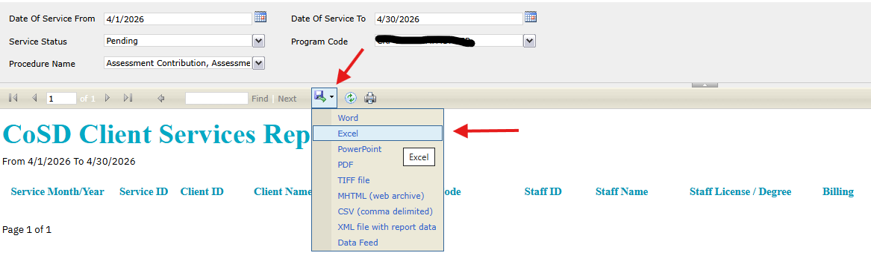

- Filter Report by Client Name
  - This will allow you to count the number of encounters/contacts provided to the client and whether the service is eligible for the bundled rate.
    - Was the encounter Face to Face with the client or was the contact a collateral contact or non-face to face encounter with client?
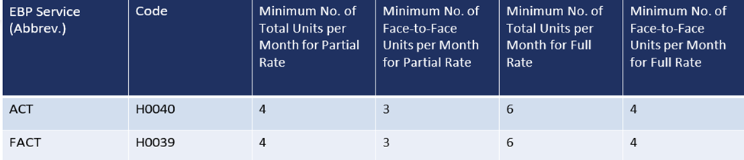
  - Once you have identified whether the client will meet for the Full or Partial Bundled Rate and if there are services that will need to be unbundled, you will need to edit the service details for each service note to prepare the services to be go through the nightly job and billing process.
  - Edits to the service notes to change the MOD and Status will need to be completed by the provider who authored the service note using the Edit button which will create a new version of the service note so that the PDF aligns with the service and allows for tracking and review of previous versions for audit purposes.

