MINI-COG ™

GET THE PATIENT’S ATTENTION, THEN SAY: “I am going to say three words that I want you to remember now and later. The words are

Banana Sunrise Chair.
Please say them for me now.” (Give the patient 3 tries to repeat the words. If unable after 3 tries, go to next item.)
(Fold this page back at the TWO dotted lines BELOW to make a blank space and cover the memory words. Hand the patient a pencil/pen).
- SAY ALL THE FOLLOWING PHRASES IN THE ORDER INDICATED: “Please draw a clock in the space below. Start by drawing a large circle. Put all the numbers in the circle and set the hands to show 11:10 (10 past 11).” If subject has not finished clock drawing in 3 minutes, discontinue and ask for recall items.

- SAY: “What were the three words I asked you to remember?”

_ (Score 1 point for each) 3-Item Recall Score

Score the clock (see other side for instructions): Normal clock 2 points Clock Score
Abnormal clock 0 points

Total Score = 3-item recall plus clock score 0, 1, or 2 possible impairment; 3, 4, or 5 suggests no impairment

Mini-CogTM Copyright S Borson. Reprinted with permission of the author, solely for clinical and teaching use. May not be modified or used for research without permission of the author (soob@uw.edu). All rights reserved.

CLOCK SCORING

NORMAL CLOCK

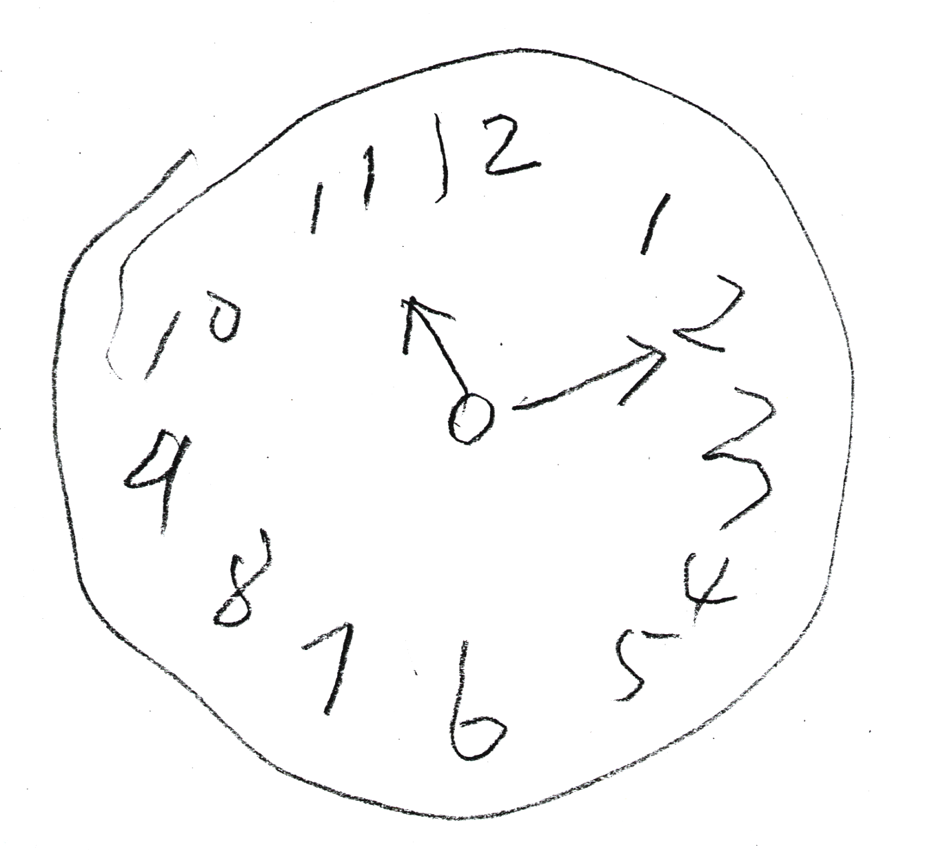
A NORMAL CLOCK HAS ALL OF THE FOLLOWING ELEMENTS:
All numbers 1-12, each only once, are present in the correct order and direction (clockwise) inside the circle.
Two hands are present, one pointing to 11 and one pointing to 2.

ANY CLOCK MISSING ANY OF THESE ELEMENTS IS SCORED ABNORMAL. REFUSAL TO DRAW A CLOCK IS SCORED ABNORMAL.

SOME EXAMPLES OF ABNORMAL CLOCKS (THERE ARE MANY OTHER KINDS)

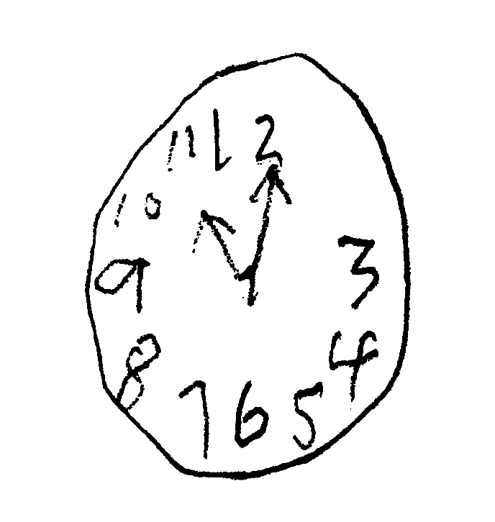

Abnormal Hands Missing Number

Mini-CogTM Copyright S Borson. Reprinted with permission of the author, solely for clinical and teaching use. May not be modified or used for research without permission of the author (soob@uw.edu). All rights reserved.

